From the MSDN:

Volatile registers are scratch registers presumed by the caller to be destroyed across a call. Nonvolatile registers are required to retain their values across a function call and must be saved by the callee if used.

Non-volatile register:
RBX
RBP
RDI
RSI
RSP
R12
R13
R14
R15
XMM6-XMM15 (This is the low part of the YMM register)

Volatile register:

RAX
RCX
RDX
R8
R9
R10
R11
XMM0-XMM5
YMM0-YMM5

YMM6-YMM15 only the upper 128 bit are volatile.

The YMM register is a 256 bit register.

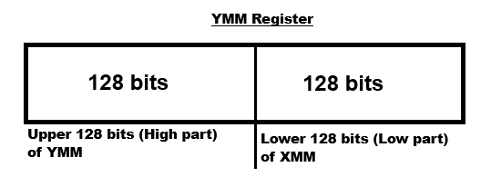

What does volatile register mean?

mov rax, 1 | RAX = 1
call AnyWindowsApiFunction
After the function call rax is not holding its previous value anymore. Because the value was changed inside of the function.

What does non-volatile register mean?

mov rbx, 1 | RBX = 1
call AnyWindowsApiFunction
After the function call rbx is still holding the value 1 because the function has not changed the value of rbx.

Who is the caller and who is the callee?

The code that calls a function is the caller and the function that was called is the calle.

call AnyFunction ; Caller

AnyFunction: ; Callee
….. any code
ret

How the code gets called that we have written:
After the C-Runtime has finished its job then it jumps to the code that we have written.

